**BUG REPORT FILE**

**BUGS FOUND IN THE PROJECT ARE:-**

1. When player wins match 1,Balance not increased
2. The limit set to 0 but Game end still player have 5 dollars
3. Odds in the game do not appear to be correct.

(Crown and Anchor games have an approximate 8% bias to the house. So the win: (win+lose) ratio

1. Currently no welcome message is there
2. The **difficulty** in checking all games (change no. of game 100 to 10).

**SOLUTION OF BUGS:-**

# When player wins match 1, Balance not increased

**Before:**

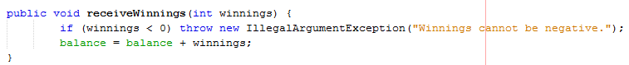

## Before Result:-

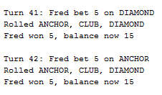

After:

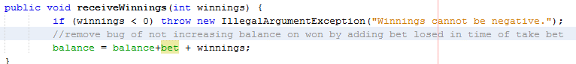

## After Result:-

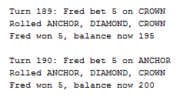

# The limit set to 0 but Game end still player have 5 dollars.

**Before:**

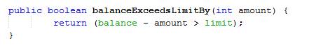

## Before result:-

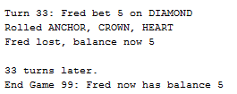

After:

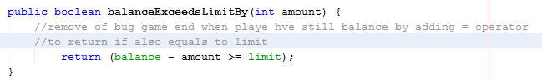

## After result:-

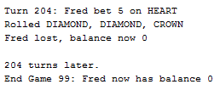

# Odds in the game do not appear to be correct.

## Before:

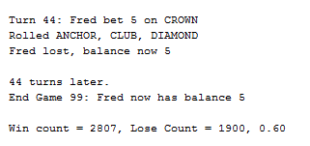

## After: After fixing all above bugs rate auto change

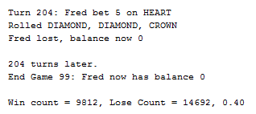

# No welcome message.

## Before:

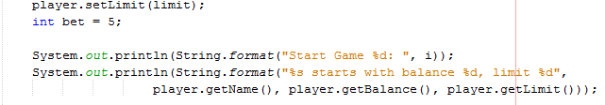

## Before result:-

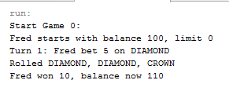

## After:

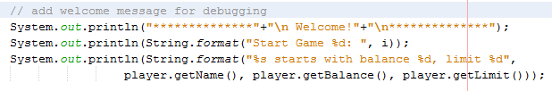

## After result:-

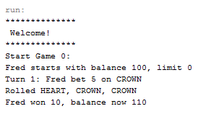

# The difficulty in checking all game(change no. of game 100 to 10).

## Before:

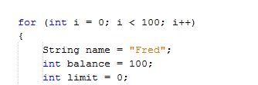

## Before result:-

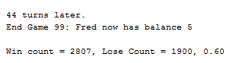

## After:



## After result:-

